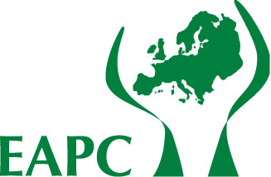 | European Association for Palliative Care  EAPC Onlus: Non profit-making Association  Non Governamental Organisation (NGO) recognised by the Council of Europe  Association Européenne pour les Soins Palliatifs  EAPC Onlus: Organisation à but non lucratifs d’utilité publique  ONG reconnue par le Conseil de l’Europe
Visit our Web – Visitez notre site Internet: http://www.eapcnet.org

Applicant’s form

First name:
Surname/family name:
Title: (Dr / Mrs / Miss / Ms / Mr / Rev ) | Age (optional)
Contact telephone - Daytime:
Contact telephone - Mobile:
Fax:
E-Mail:

What is your professional background?
√
Doctor
Nurse
Social Worker
Psychologist
Chaplain/Spiritual Care Adviser
Other

In which area of palliative care practice do you currently work?
√
In-patient unit
Home Care
Hospital Team
Day Hospital
Other

If “other” please indicate………………………………………………………………………

Please outline your professional experience in palliative care to date (in no more than 300 words)

Please explain why you wish to apply for this placement (150 words maximum)

Please list between three – four specific learning needs for you in this stage/placement?

What is the maximum length of time you are able to take a placement for?
√
1 week Yes
2 weeks Yes
Other ………………. Yes

Are you competent in the language of the country you wish to visit?
Yes No

Please write any specific requirements you have in the box below (e.g. dietary, accommodation, etc).

Please enclose a letter of recommendation to support your application (one should be from your current institution/employer).

You will be contacted following your stag/placement so we can assess the benefit and quality of your experiences.

Signature ………………………………………………………Date ………………………………….

Please forward this application form direct to your Host Centre of choice.

